Dariya Darshan Hotel
Devka Beach,
Nani Daman - 396210 [U.T]
Dariya Darshan Hotel is located at sea face road Devka Beach is one of the oldest and best Luxury hotel in daman. It is a perfect spot with natural beauty and breeze, which swings the mood. Our Hotel with Restaurants & Bar and live orchestra. Best destination for relax stay, wedding party plot, Banquet conference hall for meetings & events at daman.

Facilities

acilities
Restaurant and Bar. Banquet / Conference Halls. Accept Major Credit Cards. Swimming Pool. Car Rental. Money Exchange Counter. Safe Deposit Box. Car Parking. Doctor on Call. Reception Room Service. Travel Desk. Wi-Fi Internet Connection. Wake up Services. Laundry and Drycleaning Services.
Dining : | Room Service : | Galaxy :
  Feta-Ni-Wadi :
  Open air Garden Restaurant
  Serves Multi-cuisine and specialized in sea food
  Every weekend live musical orchestra
  Serves variety of sprits and exotic cocktails and mocktails
  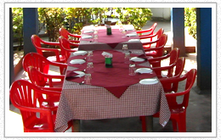
  Round the Clock Service
  Serving Indian, continental and Chinese cuisine
  Sea Facing A/C hall
  Capacity up to 100 persons
  Equipped with stage, screen, projector and mike system.

Darshan Party Plot :

Out Door Catering :

Entertainment and Leisure :
Open Air Party plot with stage
Capacity up to 50 to 500 persons
Events such as marriage reception, various exhibitions, 31st night etc is held.
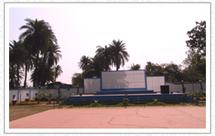

we cater out side our premises
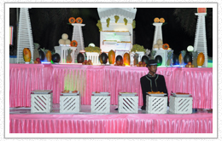

Every weekend Live Musical orchestra at Feta - Ni-Wadi Restaurant
Pan Parlour for pan and shopping
Bon-fire during winter
Children-park
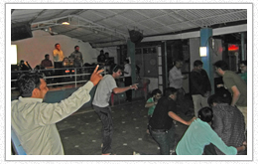

Banquets and conferences :
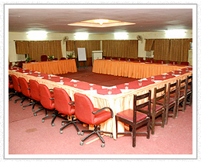

TARIFF:
Room Type |  | Per Night Tariff
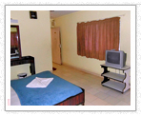 |  | Rs. 2600/-
  Deluxe A/C [2 persons]
  T.V A.C Hot & Cold Water Bath Towel Soap
  Shampoo & Medikit.
  Mount View & Backside Face
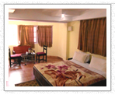 |  | Rs. 3000/-
  Super Deluxe A/C [2 persons]
  T.V A.C Hot & Cold Water Bath Towel Soap
  Shampoo & Medikit.
  Bath Tub & Mini Frize
  Mount View & Frontside Face
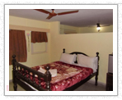 |  | Rs. 3500/-
  Exe Deluxe [2 persons]
  T.V A.C Hot & Cold Water Bath Towel Soap
  Shampoo & Medikit.
  Bath Tub & Mini Frize
  01 Bed Room & 01 Dinning Room
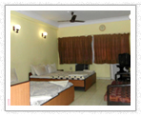 |  | Rs. 4400/-
  D.D. Comforts A/C [4 persons]
  T.V A.C Hot & Cold Water Bath Towel Soap
  Shampoo & Medikit.
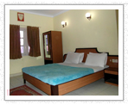 |  | Rs. 5500/-
  D.D. Special A/C [4 persons]
  T.V A.C Hot & Cold Water Bath Towel Soap
  Shampoo & Medikit.
  2 in 1 Room
  2 A.C.
  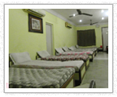
    Picnic Special A/C [8 persons]
    T.V A.C Hot & Cold Water Bath Towel Soap Shampoo & Medikit.
    A.C. & 2 Toilet
    Rs. 6600/- per Night
  Extra Person/Mattress
  Rs. 500/- per Night

CHECK IN - 12.00PM | CHECK OUT – 11.00AM

 | Child Below 5 yrs will be Free
 | Live Musical Program at "Feta Ni Wadi" Garden Restaurant. (On Every Saturday, Sunday & Occasionally)
 | 24 HRS Room Service, Doctor on Call, In House Laundry
 | Spacious Parking Area, Children Play Ground
 | All Guests to D.D.H must carry identification proof in the Form of a Govt. Issued ID
Room Amenities  - Health Club etc. Banquet A/c Hall. Restaurents & Bar. Party Plot. Conference Hall.  Activities  - Jampore Beach Resort.  - Devka Amusement Park.  - Daman Darshan. | All Rates are subject to change without prior Notice.

